ST MARY’S CATHOLIC PRIMARY SCHOOL

Feedback Policy



Policy No: | Version: | 1
Policy No: | Author: | SENIOR LEADERSHIP
Policy No: | Committee: | CURRICULUM
Policy No: | Minute No:
Policy No: | Date Issued: | October 2025
Policy No: | Review Date: | October 2026

Feedback Policy
Feedback comes in a variety of forms and should be a regular and robust part of every lesson. Feedback, as an integral part of the learning process, must be precisely positioned and delivered regularly in each aspect of the lesson. All feedback should have a positive tone. It should be specific, clear and appropriate in its purpose and productive in its outcomes. The best feedback, whether it is written or verbal, will give pupils a clear sense of how they can improve, with pupils responding and making progress as a result.
At St Mary’s Catholic Primary School, we believe that:
- The sole focus of feedback should be to further children’s learning.
- Evidence of feedback is incidental to the process; we do not provide additional evidence for external verification.
- Feedback should empower children to take responsibility for improving their own work; it should not take away from this responsibility by adults doing the hard thinking work for the pupil.
- Written comments are not required for every piece of work; teachers make their own professional judgement about when a written comment would be beneficial.
- Children should receive feedback either within the lesson itself or it in the next appropriate lesson.
- The ‘next step’ is usually the next lesson.
- Feedback is a part of the school’s wider assessment processes which aim to provide an appropriate level of challenge to pupils in lessons, allowing them to make good progress.
- New learning is fragile and usually forgotten unless explicit steps are taken over time to revisit and refresh learning. Teachers should be wary of assuming that children have securely learnt material based on evidence drawn close to the point of teaching it.
- Therefore, teachers will need to get feedback at some distance from the original teaching input when assessing if learning is now secure.
Principles
Our feedback policy is underpinned by three key principles: ‘it should be meaningful, manageable and motivating’.
Meaningful
Feedback should be specific, accurate and clear. It should provide pupils with strategies to improve, encourage them to take pride in their work and present their work neatly. It should also help them correct errors in their work. The type of feedback will vary by age group, subject and what works best for the pupil in relation to any particular piece of work. Our teachers are encouraged to use their professional judgement to decide what type of feedback is appropriate and will most positively impact on that child’s progress. Teachers are expected to adjust their approach as necessary and trusted to incorporate the outcomes into subsequent planning and teaching.
Manageable
We do not expect to see any specific frequency, type or volume of marking and feedback. Not all pieces of work will be formally marked. We also do not expect to see any written record of oral feedback provided to pupils, unless it is useful for the teacher, teaching assistant or child to do so.
Motivating
Feedback should help to motivate pupils to progress, encourage and support further effort. This does not mean always writing in-depth comments or being universally positive: sometimes short, challenging comments or oral feedback are more effective.
Effective Feedback
Effective feedback may be used in any subject where the teacher feels this is appropriate. ‘Effective Feedback’ is whole class feedback at the start of the next lesson. It starts with ‘praise and share’ of children’s work from the previous lesson. A gold star in the book will indicate that the child’s work is being used for ‘praise and share’. This will give specific praise as an example to the rest of the class. The teacher will then discuss any misconceptions, common spelling errors or further comments from the previous lesson that need to be addressed. Children will have time to respond to the feedback and can make edits/corrections using black pen.
Specific Feedback in different subjects
- English
Staff are required to invest time in reading the work to identify where learners need to improve. However, they are not required to always write this individually in each book.
The impact of feedback will be seen in the editing or future pieces of work where the child shows they have improved /made progress. The type of feedback given will vary depending on the subject, lesson and context. The teacher will use the guide below to support their professional judgement about the type of feedback required.

Lesson outcome | Feedback suggestions
Work that was completed whole class e.g. analysing WAGOLL, vocabulary collection/ generation, ‘magpie’ing, sequencing etc. | - Teacher to check the work is complete.  - Tick to say it has been checked.
Lessons where the focus is on planning a piece of writing. | - Check it makes sense and correct any obvious errors.  - Tick to say it has been checked
Sentence or grammar work e.g. relative clauses, expanded noun phrases. | - Highlight where the skill has been used correctly in the work.  - Use the marking code to draw attention to transcription issues.  - No comment required.
Longer written pieces. | Highlight (in yellow):  - evidence of criteria discussed / taught in the topic  - criteria that relate to year group assessment statements.  - Parts that wow  Use the marking code in green pen to highlight:  - Transcription issues (spelling & handwriting)  - Grammar errors  - Parts that need revision / editing.  - Give a positive about their work.  Gold Star Stamp:    - Given for extraordinary work and effort with clearly explained reason why. The work is to be shared during praise and share in the next lesson.

Early Years and Key Stage 1:

F2, Year 1 and Year 2 have a stamp which staff highlight in yellow to indicate whether children have achieved writing objectives. This serves as a reminder and a motivation for children about what they need to include in their writing.

Stamp used in FS2 from term 5 and throughout Year 1:

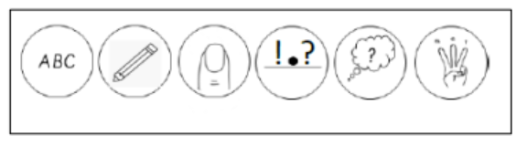

Marking code:

Stamp used in Year 2:
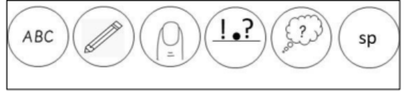

Marking code used in Year 1 and Year 2:

 | Missing punctuation, capital letters or incorrect letter formation.
 | Spelling mistake - correct it in the work. Check the rest of the piece for the same spelling. Add children’s common spellings errors to the blank bookmark (maximum of 3 with a focus on red words.)
 | A gold stamp to show the work is worthy of ‘praise and share’.

Marking code in Key Stage 2:

 | Missing punctuation, capital letters or incorrect letter formation.
 | Something missing. Fliers
 | Grammar/cohesion error.
 | Spelling mistake - correct it in the work. Check the rest of the piece for the same spelling. Add children’s common spellings errors to the blank bookmark (maximum of 3).
 | Focus on this part – tell the children what is missing or needed here.
 | New paragraph needed.
 | A gold stamp to show the work is worthy of ‘praise and share’.

- Maths:
- Staff highlight correct answers using a yellow highlighter and incorrect answers using a green highlighter. The majority of this will happen during the lesson as children are working so that they can immediately see if they are being successful.
- Verbal feedback is given immediately where corrections need to be made.
- If it is clear that the child has a misconception, then this will be addressed with the teacher or LSA.

Marking stamp used in maths:
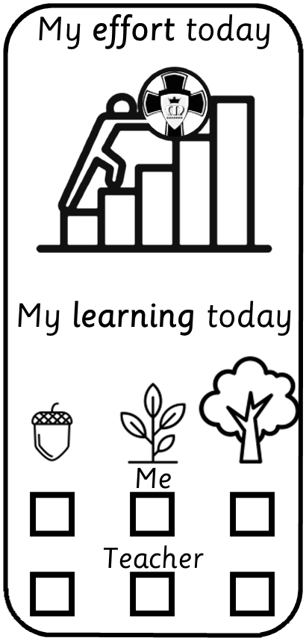
The marking stamp will be used at the end of the piece of work to show whether the child has achieved the objective, is in the process of achieving the objective or they have not yet achieved the objective. If so, the child will require further support or intervention. It will also show the effort level of the child. A child can achieve a maximum of 5.

- RE
Feedback should be linked to the pupil targets/next steps. Children need to know what they have done well and what their next steps are in R.E.
- Evidence of learning for every lesson
This is inclusive of but not limited to: labels/annotations, Thinking Maps, speech/thought bubbles, written work, photos/Pic Collage, artwork, ICT etc.
- Feedback given verbally live throughout the lesson.
- Marking stickers used in most lessons:

Pupils (Y2-Y6):  - self-assess understanding: acorn (beginning to), shoot (confident), oak tree (fully secure)  - tick what helped them to learn |  | Staff:  - teacher highlight level of effort from 1 step lowest - 5 steps highest  - teacher-asses for content (acorn, shoot, oak tree)  - identify mis-spelling of star words and other important religious vocabulary

- Mark for content generally – teacher assess using symbols on the marking stamper.
- No generic praise stickers – children can be sent to the office for RE Award stickers or Head Teachers stickers.
- ‘Praise and Share’ used to highlight golden examples within the children’s work.
- Targets highlighted on the front cover of RE books – linked to age-related skills for each lens (Understand, Discern, Respond)
*For clarity, a range of driver words are now incorporated within the RED branches rather than one/two particular driver words year group
Year 1  Talk about  Recognise  Encounter  Recall  Retell  Identify  Make simple connections  Make links | Year 2  Retell  Recall  Recognise  Describe  Talk about  Make connections  Give examples  Use religious vocabulary | Year 3  Revisit  Remember  Retell  Recognise  Make simple links  Describe  Use religious language  Know  Show simple understanding  Use examples  Know
Year 4  Show some understanding  Make links  Make connections  Describe  Recognise  Know  Use religious vocab  Sequence  Recount | Year 5  Explain  Describe  Use specialist vocab  Know  Make links  Recognise | Year 6  Show understanding  Recognise  Explain  Use theological vocabulary  Describe  Make links and connections  Know

- Foundation subjects:
Feedback in foundation subjects should primarily relate to the skills and knowledge specific
to that subject.

- Incorrect spellings, especially those linked to the key vocabulary, are identified using the marking code.
- Where these spellings are noted as a common misconception, they can be shared during the effective feedback session at the start of the next lesson.
- Children will also be directed to check their blank bookmark spellings.
- The same marking code applies in Foundation subjects as it does in English.
- Children will make edits, redrafts and corrections in black pen.

The teacher will highlight on the marking stamp to show the child’s effort level.
There are 5 bars available for the children to earn. 5 being for when the child has gone above and beyond with their effort levels down to 0 bars for if it is clear that the child has not tried. School would expect children to be getting 3 bars and above for most lessons.

Presentation in all subjects and year groups

All staff should have high expectations of presentation in books. Children should be reminded about presentation at all times and always encouraged to take pride in their work. If work is not presented well this should be addressed during lessons and children should be encouraged to re-focus on this. If necessary, staff can write ‘P’ in the margin so an improvement can be seen from this point. If this is a target for the pupil, then it should be written on their bookmark target. If the reminder is retrospective, children can be asked to rewrite certain parts or use the bookmark targets to create a reminder for them.

Adaptions for pupils with SEND
Some pupils with SEND may find it more difficult for them to edit their own work and may need a greater the degree of scaffolding. Instead of going back and trying to edit/ improve the last piece of work, they may be given a new task to practice the same skill.
Spelling corrections should be linked to their individual targets (e.g. High frequency words)
Monitoring the impact of feedback
Senior Leaders will provide support and development related to feedback as part of every induction process and review and revisit core strategies every year.
All staff should share in the expectation and responsibility that all pupils will progress in their learning.
A range of evidence will be triangulated in partnership between teachers and senior leaders when looking at the quality and impact of feedback at St Mary’s. Evidence of feedback can be found by talking to the teacher and pupils and by looking at their work. This will be done during lesson observations, learning walks, informal/formal meetings with teachers, pupil interviews, pupil progress meetings and book looks.

